
Hazelwood Schools

Music
Curriculum Overview

Music at Hazelwood
Intent
At Hazelwood Schools, we are proud to provide a rich and diverse experience of music for all of our children.
We believe that music has a positive impact on children’s personal and creative development as well as all areas of learning.
As part of our Music curriculum, we provide opportunities for children to express themselves creatively, build confidence, develop coordination and enhance their communication skills. Music is a universal language, connecting us and bringing us together as a whole community.

The aims of our Music Curriculum are:

- To provide real, relevant, immersive and purposeful opportunities for children to develop skills in singing, listening, composing and performing
- To listen to, review and evaluate music across a range of historical periods, genres and traditions
- To sing and use voices creatively
- To create and compose
- To learn to play a variety of musical instruments
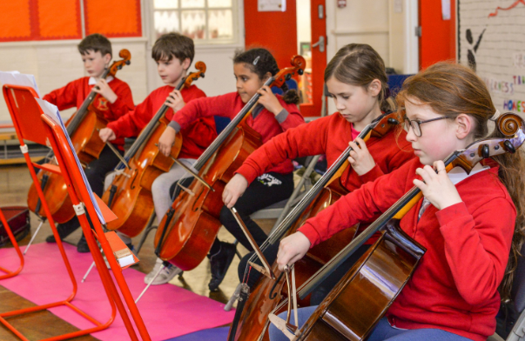
- To develop an understanding of music and its inter related dimensions: pitch, duration, dynamics, tempo, timbre, texture, structure and musical notations
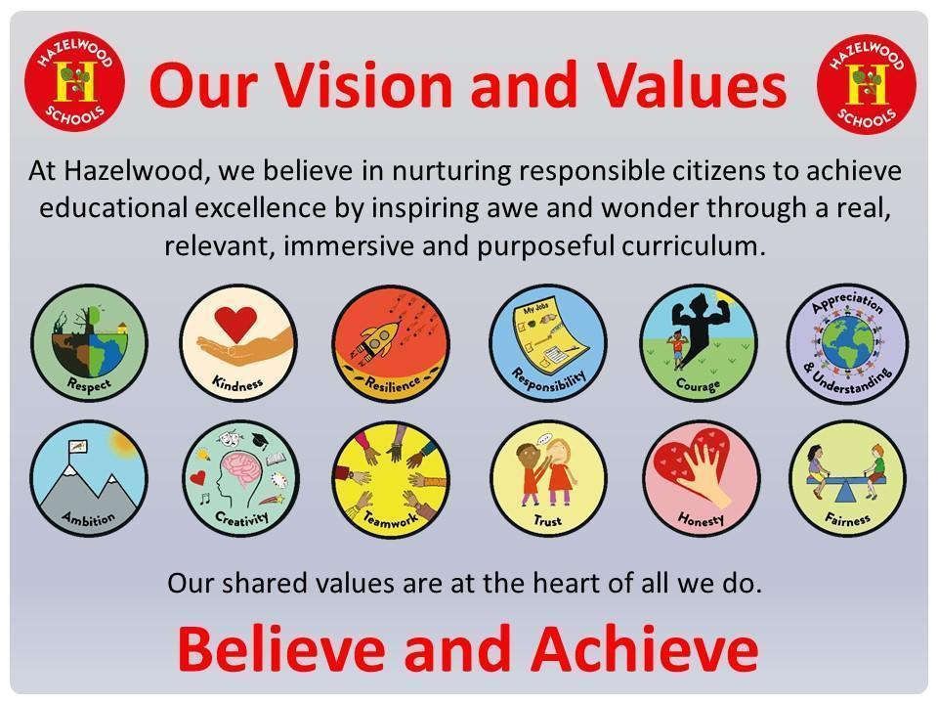

Implementation
At Hazelwood, Music is taught discreetly every week. Children also take part in a weekly singing assembly. Whole class instrumental lessons take place in Year 2 and throughout KS2.
Key musical concepts are built upon and learning is revisited to ensure children’ knowledge is built upon each week and year on year. The Hazelwood Curriculum is built upon the Model Music Curriculum due to its focus on diversity both in pieces of music and in skills. The curriculum is ambitious in its scope (meeting and exceeding the demands of the National Curriculum), meticulous in rigour (responsive to up-to-date scholarship in music) and carefully sequenced (so that pupils’ ability to build a comparison and reach a critical judgment).
Music is also used to enhance and support learning other subjects such as Maths, Geography, PSHE and English. In EYFS, Music supports children in learning routines, nursery rhymes, stories and behaviour expectations. In Spanish, Music is used to introduce new language learning.
Hazelwood’s Approach to Teaching and Learning
At Hazelwood, you will see a range of real, relevant, immersive and purposeful learning opportunities within a nurturing, enabling environment, including the following approaches to teaching and learning:
  - Children exploring and answering big questions which allow them to think deeply about their learning
  - Children hearing and using key vocabulary in a range of contexts
  - Children speaking in full sentences using the key vocabulary taught
  - Cold calling - supporting all children in engaging in their learning and believing they can achieve
  - Adaptive teaching - responding to the needs of all children
  - Retrieval practice – allowing children to know more, remember more and do more
  - Positive relationships and quality interactions that nurture our responsible citizens
  - Spaced and sequential learning over time to help children learn more quickly and remember learning better.
In a typical Music unit, you will see:
- Children learning to use their voices with increasing control and precision
- Children learning to sing together and follow musical instructions
- Children learning to use instruments with care and respect
- Children learning to play tuned and untuned percussion instruments rhythmically
- Children learning to listen and appraise a variety of music
- Children learning to notate and compose music using a variety of instruments
- Children responding to music with movement
- Children performing solo or in groups to each other or a larger audience
- Children putting music genres, compositions and composers into historical contexts
- Children learning to identify and comment on the inter-related dimensions of music

Real, relevant and immersive learning opportunities in Music are really important in supporting children to explore their sense of self, creatively. Music helps children express their opinions and emotions and gives them a creative outlet that is accessible for everyone. Music supports early language development and language acquisition, enabling children to communicate more effectively. Our children have the opportunity to sing, perform and be creative with music in a variety of contexts.
To further enhance the Music curriculum, we provide choirs and instrumental ensembles, enabling them to develop their passion and skills in Music. We work closely with the Enfield Music Service which provide opportunities to share music with local schools and inspires children with shared music making experiences.

Impact
How do we assess?
We assess our children using a range of methods
- In instrumental lessons, children sit in small groups to enable individual support and assessment of their skill level.
- Routine, embedded, informal formative assessment is built into every lesson.
- Questioning is a large part of our assessment. We use a range of questions to constantly check children's knowledge is secure and that children are able to identify inter-related dimensions of music in piece they are playing or listening to.
- Children take part in call and response activities as a whole class.
- Children are given the opportunity to sing or perform solo to demonstrate their skill and understanding of the techniques taught.
- Summative assessment is recorded termly on Scholar Pack, identifying those working at ARE, as well as those below and above ARE.

How do we know that children are at age-related expectation?
- Children are able to identify taught inter-related dimension of music in music listened to.
- Children are able to use taught musical vocabulary to talk about music.
- Children sing and perform applying taught techniques and skills with confidence.
- Children achieve the Hazelwood Music Curriculum end of unit outcomes.
Children are working at a greater depth if they question the methods composers have used to create effects, comment on inter-related musical dimensions and how they have been used to evoke a particular feeling and draw on their own life experiences to understand the impact music has on the world around them.

How do our children feel about Music?
- “I like dancing when the music is on.” - Reception
- “I like playing instruments and singing songs.” - Reception
- “I like learning new songs and playing instruments I don’t know.” - Year 1
- “I like that you can show how you are feeling through music.” - Year 1
- “There is so much spirit in music and you can make any sound you want.” - Year 2
- “Music can take you to different places depending on the sounds you hear.” - Year 2
- “I like how you get to express your feelings while singing and that you get to be yourself.” - Year 3
- “I like learning music because it can give you a more creative mind.” - Year 3
- “I like to hear music that I have never heard before.” - Year 4
- “You get to learn songs and invent new ones.” - Year 4
- “Music lessons are fun and engaging and no one is ever left out because music is in everybody.” - Year 5
- “We got the opportunity to learn an instrument and give a concert.” - Year 6
- “I like that we are introduced to new sounds.” - Year 6
RECEPTION | EXPRESSIVE ARTS AND DESIGN  EYFS Statutory Framework (2021): Educational Programme  The development of children’s artistic and cultural awareness supports their imagination and creativity. It is important that children have regular opportunities to engage with the arts, enabling them to explore and play with a wide range of media and materials. The quality and variety of what children see, hear and participate in is crucial for developing their understanding, self-expression, vocabulary and ability to communicate through the arts. The frequency, repetition and depth of their experiences are fundamental to their progress in interpreting and appreciating what they hear, respond to and observe.  (Linked Early learning goals: communication and language, physical development, personal, social and emotional development)
RECEPTION | AUTUMN 1 |  | AUTUMN 2 | SPRING 1 | SPRING 2 | SUMMER 1 | SUMMER 2
RECEPTION | Finding my voice  Skills  - Singing  - Performing  Inter-related dimensions of music  - Tempo  - Structure  - Pitch  - Dynamics  Duration | Using my voice  Skills  - Singing  - Performing  Inter-related dimensions of music  - Tempo  - Structure  - Pitch  - Dynamics  Duration |  | Using instruments  Skills  - Contextualising  - Listening  Inter-related dimensions of music  - Timbre  - Texture  - Silence |  | Making music together  Skills  - Composing  - Notating  - Singing  - Performing  - Listening  Inter-related dimensions of music  - Timbre  - Texture  - Pitch  - Tempo  - Structure  - Dynamics  - Duration
Vocabulary | - music  - repeat  - fast/ slow  - melody/ tune  - start /stop  - together/ unison  - jingle bells  - drum  - instrument  - loud/ quiet/ soft  - whisper/ shout  - leader | - perform  - pulse  - beat  - rhythm  - high/low  - parts  - long/ short  - tempo  - dynamics  - structure  - pitch  - duration |  | - timbre  - texture  - layers  - percussion  - sound  - maraca  - claves  - instrument  - hand drum  - guiro  - beater  - egg shaker  - toad scarper  - rainstick  - triangle  - wooden agogo  - wood block  - silence  - pattern  - notes  - compare  - express  - shake/ strike/ scrape |  | - call/ response  - conductor/ leader  - higher/ lower  - unison/ solo  - voice  - choir  - chant  - compose  - invent/ improvise  - audience  - accompany  - performance  - signal  - pulse/ rhythm  - notate/ record  - perform  - share  - listen/ hear

 | AUTUMN 1 | AUTUMN 2 | SPRING 1 | SPRING 2 | SUMMER 1 | SUMMER 2
YEAR 1 | Peter and the Wolf by Sergei Prokofiev  Skills  - Listening  - Contextualising  Inter-related dimensions of music  - Pitch  - Timbre | The Nativity  Skills  - Singing  - Performing  Inter-related dimensions of music  - Pitch  - Tempo  - Structure  - Dynamics | Musical story  Skills  - Listening  - Contextualising  Inter-related dimensions of music  - Dynamics  - Tempo  - Duration | Make some noise!  Skills  - Singing  - Composing  - Performing  Inter-related dimensions of music  - Timbre  - Dynamics  - Silence  - Texture  - Tempo | Let’s sing together  Skills  - Singing  - Performing  - Contextualising  Inter-related dimensions of music  - Pitch  - Dynamics  - Duration | By the seaside  Skills  - Notating  - Composing  - Performing  Inter-related dimensions of music  - Texture  - Timbre  - Dynamics  - Duration
Vocabulary  New to Y1 | - bassoon  - strings  - violin  - clarinet  - oboe  - flute  - French horn  - timpani  - Early 20th Century  - classical  - genre  - orchestra  - composer  - same/ different  - high/low  - timbre  - pitch  - melody/ tune  - conductor/ leader  - higher/ lower  - compare | - project/ whisper/ shout  - verse  - chorus  - structure  - purpose  - share  - solo/ unison/ together  - perform/ers  - performance  - audience  - sing/ers  - high/er  - low/er  - pitch  - loud/er  - quiet/er  - dynamics  - call/ response  - voice  - choir  - tempo  - fast/er  - slow/er  - beat/ pulse/ rhythm  - conductor/ leader  - repeat/ copy  - start/ stop  - melody/ tune  - jingle bells | - dance scarves  - movement  - dynamics  - loud/quiet  - crescendo  - diminuendo  - tempo  - pulse  - rhythm  - fast/slow  - duration  - long/short  - classical  - genre  - orchestra  - composer  - melody/ tine | - rest  - tempo  - fast/ slow  - rhythm  - pulse  - dynamics  - loud/quiet  - crescendo  - diminuendo  - timbre  - texture  - layers  - thick/thin  - percussion  - maraca  - claves  - instrument  - hand drum  - guiro  - beater  - egg shaker  - toad scarper  - rainstick  - triangle  - wooden agogo  - wood block  - pattern  - notes  - shake/ strike/ scrape  - start/ stop  - graphic notation  - notating  - composing  - composer  - silence/ sound | - volume  - forte/ piano  - purpose  - pitch  - high/ er  - low/er  - dynamics  - loud/quiet  - crescendo  - diminuendo  - duration  - long/short  - repeat/ copy  - start/ stop  - solo/ unison/ together  - call/ response  - project/ shout/ whisper  - audience  - perform/ performance  - melody/ tune | - soundscape  - graphic notation  - composition/ compose  - improvise/ invent  - texture  - thick/thin  - layers  - timbre  - same/ different  - compare  - dynamics  - loud/ quiet  - piano/ forte  - crescendo  - diminuendo  - duration  - long/ short  - notate/ record  - percussion instruments  - claves/ guiro/ hand drum/ triangle/ beater/ wooden agogo/ jingle bells/ maracas/ wood block

 | AUTUMN 1 | AUTUMN 2 |  | SPRING 1 |  | SPRING 2 |  | SUMMER 1 |  | SUMMER 2
YEAR 2 | The Carnival of the animals by Camille Saint-Saens  Skills  - Listening  - Composing  - Notating  - Performing  Inter-related di  mensions of music  - Tempo  - Dynamics  - Pitch  - Timbre |  | The Little Train of Caipira by Heitor Villa-Lobos  Skills  - Listening  - Contextualising  - Performing  Inter-related dimensions of music  - Tempo  - Duration  - Structure  - Dynamics  - Timbre |  | Learning to play the tin whistle  Skills  - Performing  - Singing  - Listening  - Notating  Inter-related dimensions of music  - Pitch  - Tempo  - Duration  - Silence |  | Stone Age  Skills  - Singing  - Contextualising  - Composing  Inter-related dimensions of music  - Dynamics  - Tempo |  | Oceans  Skills  - Composing  - Notating  Inter-related dimensions of music  - Dynamics  - Timbre  - Silence  - Duration  - Texture  - Structure
Vocabulary  New to Y2 | - accelerando  - pitch pattern/ melody/ tune  - cello  - piano  - double bass  - waltz  - xylophone  - clarinet  - strings  - violin  - flute  - tempo  - fast/ slow  - rhythm  - beat/ pulse  - dynamics  - loud/ quiet  - forte/ piano  - crescendo/ diminuendo  - pitch  - high/ low  - Early 20th Century  - genre  - classical  - Orchestra  - graphic notation  - composition/ composer  - notate/ record  - performance/ perform  - timbre |  | - rallentando  - reco-reco  - ganza  - ratchet  - conductor’s baton  - woodwind  - brass  - tempo  - piano  - fast/ slow  - rhythm  - beat/ pulse  - accelerando  - duration  - long/ short  - structure  - parts  - dynamics  - loud/ quiet  - forte/ piano  - crescendo/ diminuendo  - timbre  - conductor  - orchestra  - strings  - percussion |  | - tube  - tone holes  - windway  - blade  - fipple  - mouthpiece  - tongueing  - diaphragm  - woodwind  - instrument  - blowing/ blown  - tin whistle  - whistle  - breath  - left/ right  - finger pads  - crotchet  - quaver  - rest  - minim  - notes: BAG  - improvisation/ improvise  - tempo  - fast/ slow  - rhythm  - beat/ pulse  - pitch  - high/ low  - duration  - long/ short  - silence/ sound  - rest  - melody/ tune/ pitch pattern |  | - rap  - question and answer  - rhyme  - phrase  - in time  - repetition/ repeat  - call/ response  - tempo  - fast/ slow  - rhythm  - beat/ pulse  - dynamics  - loud/ quiet  - forte/ piano  - crescendo/ diminuendo  - leader |  | - ABC/ beginning/ middle/ end  - ocean drum  - tingsha bell  - soundscape  - dynamics  - loud/ quiet  - crescendo/ diminuendo  - timbre  - same/ different  - silence/ sound  - rest  - duration  - long/ short  - texture  - layers  - thick/ thin  - structure  - compose/ composition  - graphic notation  - percussion instruments  - rainstick/ wood block/ hand drum/ guiro/ triangle/ maracas  - leader  - start/ stop

 | AUTUMN 1 | AUTUMN 2 | SPRING 1 | SPRING 2 | SUMMER 1 | SUMMER 2
YEAR 3 | Learning to play the recorder  Skills  - Contextualising  - Performing  - Singing  - Listening  Inter-related dimensions of music  - Pitch  - Tempo  - Duration  - Silence |  |  |  | The Young Persons Guide to the Orchestra by Benjamin Britten  Skills  - Contextualising  - Listening  Inter-related dimensions of music  - Dynamics  - Tempo  - Duration  - Texture  - Structure  - Timbre | Sounds of Africa  Skills  - Contextualising  - Composing  - Notating  Inter-related dimensions of music  - Tempo  - Timbre  - Texture
Vocabulary  New to Y3 | - window  - labium  - tone holes  - head joint  - foot joint  - middle joint  - double tone holes  - semibreve  - dotted minim  - dotted crotchet  - stave  - staff notation  - time signature  - treble clef  - bass clef  - bar  - barline  - musical alphabet: CDEFGAB  - flat/ sharp  - metre  - fingering  - accompaniment  - practise  - mouthpiece  - instrument  - woodwind  - tongueing  - beat  - tempo  - diaphragm  - crotchet  - minim  - rest  - note  - quaver  - pitch  - high/ low  - tempo  - fast/ slow  - rhythm/ pulse  - duration  - long/ short  - silence/ sound  - solo/ unison  - call/ response  - copy/ repeat  - conductor/ leader  - improvise/ improvisation  - melody/ tune |  |  |  | - keys  - brass  - viola  - harp  - piccolo  - trumpet  - trombone  - tuba  - contrabassoon  - drum kit  - fugue  - theme/ melody/ tune  - orchestra  - strings  - percussion  - woodwind  - genre  - Early 20th Century  - violin  - cello  - double bass  - flute  - clarinet  - oboe  - bassoon  - French Horn  - dynamics  - forte/ piano  - loud/ quiet  - crescendo/ diminuendo  - tempo  - pulse/ rhythm  - fast/ slow  - duration  - long/ short  - texture  - thick/ thin  - layers  - structure  - timbre  - claves  - maracas  - conductor/ leader  - conductor’s baton | - djembe  - caxixi  - kayamba  - kalimba/ mbira  - talking drum  - clapper drum  - balafon  - chekere  - calabash rattle  - echo  - maracas  - tempo  - pulse/ rhythm  - fast/ slow  - timbre  - texture  - thick/ thin  - layers  - improvise/ improvisation  - compose/ composition  - graphic notation  - notate/ record  - call/ response  - conductor/ leader  - repeat

 | AUTUMN 1 | AUTUMN 2 | SPRING 1 | SPRING 2 | SUMMER 1 | SUMMER 2
YEAR 4 | Learning to play the flute  Skills  - Listening  - Performing  - Singing  - Contextualising  Inter-related dimensions of music  - Pitch  - Tempo  - Duration  - Silence |  |  |  | Exploring Rag and Tal  Skills  - Singing  - Contextualising  - Performing  Inter-related dimensions of music  - Structure  - Timbre  - Tempo  - Dynamics  - Pitch | Sounds of the forest  Skills  - Composing  - Notating  - Performing  Inter-related dimensions of music  - Dynamics  - Structure  - Texture  - Timbre  - Silence
Vocabulary  New to Y4 | - case  - body  - keys  - cleaning rod  - cleaning cloth  - polishing cloth  - embouchure  - home keys  - crown  - semiquaver  - rehearse/ rehearsal  - programme  - diaphragm  - foot joint  - head joint  - woodwind  - Instrument  - tongueing  - fingering  - pitch  - high/ low  - melody/ tune  - tempo  - fast/ slow  - rhythm/ pulse  - duration  - long/ short  - silence/ sound  - rest  - quaver  - crotchet  - minim  - semibreve  - dotted minim  - dotted crotchet  - time signature  - metre  - bar  - barline  - stave  - staff notation  - musical alphabet: CDEFGAB  - solo/ unison  - call/ response  - copy/ repeat  - conductor/ leader  - treble/ bass clef  - flat/sharp  - improvise/ improvisation  - audience  - perform/ performance  - accompaniment  - practise |  |  |  | - rag/a  - tal/a  - tukda  - tabla  - tin tal  - sitar  - Northern Hindustani classical music  - matra  - offbeat/ onbeat  - speaking compositions  - rhythmic notation  - structure  - timbre  - dynamics  - loud/ quiet  - piano/ forte  - tempo  - fast/ slow  - rhythm/ pulse  - pitch  - high/ low  - melody/ tune  - xylophone  - beater  - conductor/ leader | - afuche cabasa  - ostinato/ repeated rhythm pattern  - contrast  - bongos  - two tone blocks  - overture  - metal guiro shaker  - tambourine  - dynamics  - toad scraper  - triangle  - beater  - wooden agogo  - soundscape  - loud/ quiet  - piano/ forte  - crescendo/ diminuendo  - structure: ABA  - texture  - thick/ thin  - layers  - timbre  - similar/ different  - silence/ sound  - rest  - compose/ composition  - notate/ record  - graphic notation  - conductor/ leader  - perform/ performance  - practise

 | AUTUMN 1 | AUTUMN 2 | SPRING 1 | SPRING 2 | SUMMER 1 | SUMMER 2
YEAR 5 | Sea Shanties  Skills  - Singing  - Performing  - Contextualising  - Notating  Inter-related dimensions of music  - Duration  - Tempo  - Structure | Peer Gynt Suite by Edvard Grieg  Skills  - Listening  - Contextualising  Inter-related dimensions of music  - Texture  - Dynamics  - Tempo  - Silence  - Pitch | Jazz  Skills  - Listening  - Contextualising  - Composing  - Performing  Inter-related dimensions of music  - Timbre  - Duration  - Texture | The Planets Suite by Gustav Holst  Skills  - Listening  - Contextualising  Inter-related dimensions of music  - Texture  - Silence  - Pitch  - Dynamics | Ensembles  Skills  - Singing  - Contextualising  - Listening  Inter-related dimensions of music  - Texture  - Structure | Sounds of Cyprus  Skills  - Singing  - Contextualising  - Performing  Inter-related dimensions of music  - Tempo  - Structure  - Pitch
Vocabulary  New to Y5 | - sea shanty  - short drag shanties  - long haul or halyard shanties  - capstan and pumping shanties  - round  - canon  - shantyman  - unison/ solo  - call/ response  - structure  - chorus/ verse  - duration  - long/short  - tempo  - fast/ slow  - rhythm/ pulse  - genre  - repeat/ repetition  - In time  - conductor/ leader | - Romantic era  - dotted rhythm  - effect  - ostinato/ loop  - texture  - thick/thin  - layers  - dynamics  - loud/quiet  - forte/piano  - crescendo/ diminuendo  - tempo  - rhythm/ pulse  - accelerando/ rallentando  - silence/ sound  - rest  - pitch  - high/ low  - melody/ tune/ theme  - Suite  - orchestra  - strings  - brass  - woodwind  - conductor  - percussion  - composer/ composition  - offbeat/ backbeat | - Jazz  - banjo  - saxophone  - trio  - syncopation  - scat singing  - nonsense syllables  - mimic  - quotation  - chord  - chord progression  - walking bass  - harmony  - triad  - major scale  - minor scale  - major/minor  - pentatonic scale  - double bass  - tuba  - trumpet  - cornet  - trombone  - clarinet  - Early 20th Century  - drum kit  - call and response  - improvise/ improvisation  - timbre  - smooth/ bumpy/ gravelly  - duration  - dotted rhythms  - texture  - thick/ thin | - fortissimo/ pianissimo  - mezzo forte/ mezzo piano  - chord  - chord progression  - suite  - pitch  - high/ low  - silence/sound  - rest  - texture  - layers  - thick/thin  - melody/ tune/ theme  - dynamics  - loud/ quiet  - forte/ piano  - crescendo/ diminuendo  - effect | - ensemble  - a capella  - barbershop quartet  - body percussion  - music technology  - symphony orchestra  - Baroque period  - Classical period  - sonata allegro  - minuet  - sonata  - rondo  - rock band  - electric guitar  - electric bass guitar  - lead singer  - backing vocals  - colliery band  - brass band  - tenor horns  - baritone horns  - tenor trombones  - bass trombones  - euphoniums  - flugelhorn  - cornets  - tubas  - percussion  - drum kit  - echo  - texture  - layers  - thick/thin  - structure  - parts/whole/ sections | - culture  - tradition  - bouzouki  - melody/ countermelody  - verse/ chorus  - Instrumental break  - Tsiattista poetic duelling  - lute  - double bass  - violin  - flute  - drum  - singer  - solo/unison  - pitch  - high/low  - melody/tune/theme  - tempo  - pulse/ rhythm  - fast/slow  - rap  - structure  - part/whole/section

 | AUTUMN 1 | AUTUMN 2 | SPRING 1 | SPRING 2 | SUMMER 1 | SUMMER 2
YEAR 6 | Songwriting  Skills  - Listening  - Singing  - Contextualising  - Composing  - Performing  Inter-related dimensions of music  - Pitch  - Tempo  - Structure |  | Music Technology  Skills  - Composing  - Listening  - Notating  - Contextualising  Inter-related dimensions of music  - Pitch  - Silence  - Dynamics  - Tempo  - Timbre  - Texture  - Duration |  | Musicals  Skills  - Singing  - Contextualising  - Listening  - Performing  Inter-related dimensions of music  - Structure  - Pitch  - Dynamics  - Tempo
Vocabulary  New to Y6 | - songwriting  - message/ meaning  - pop song  - memorable  - bridge  - style  - ukulele  - chord  - strum  - song  - structure  - parts/whole  - repetition/ repeat  - verse  - chorus  - rhyme  - rap  - effect  - Early 20th century  - genre  - pitch  - high/low  - melody/tune/theme  - tempo  - fast/slow  - rhythm/pulse  - singing  - voice  - perform/performer/performance  - percussion  - leader  - audience  - purpose |  | - loop  - soundbite  - record  - film music  - soundtrack  - texture  - layers  - thick/thin  - purpose  - effect  - pitch  - high/low  - melody  - silence/sound  - Rest  - dynamics  - loud/quiet  - crescendo/ diminuendo  - tempo  - fast/slow  - rhythm/pulse  - ostinato  - walking bass  - timbre  - smooth/ scratchy  - duration  - long/short  - repeat/repetition  - compose/ composition  - accompany |  | - musical theatre  - tongue twister  - warm up  - Production  - rehearsal  - stage  - wings  - project/projection  - phrasing  - diction  - singing voice  - solo/unison  - harmony  - scale  - genre  - structure  - part/whole  - pitch  - high/low  - melody/ tune/ theme  - dynamic  - loud/quiet  - tempo  - fast/slow  - pulse/rhythm

