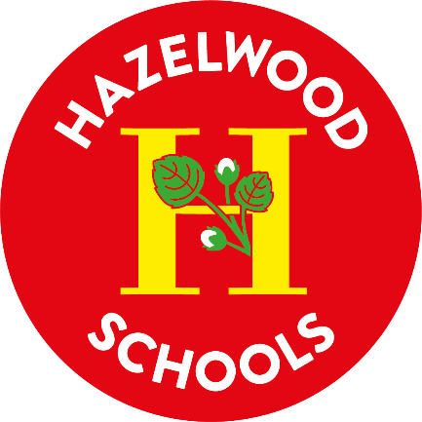

Hazelwood Schools

Privacy Statement for Young People

Reviewed: Summer Term 2026

Reviewed by: Resources Committee

Review Annually

Privacy Statement for Young People

What is this? Why is it important to me?
This explains what personal data is, why your school uses it and what your rights are.
It is important because you need to know how your data is used and what you can do if you think something is wrong.
It is an easier to read version of the school’s full privacy statement, which you can see here –
http://hazelwoodschools.org.uk

What is “personal data”?
“Data” is things we have written down or stored on a computer.
“Personal data” is data about YOU. Your name, where you live, your school marks, are all examples of personal data.

What data about me does my school use? Why?
Your school uses data about:
- You such as your name, photograph and address. This is to help us know who you are.
- Things about you such as what languages you speak and how well, where you were born and if you get free school meals. This is to help us understand what we need to help you, and to ensure we are treating everyone fairly.
- Your attendance such as what lessons you went to, how many times you missed school and why. This is because we must report on your attendance by law.
- What you have learnt and how well you did such as our lesson plans for you, your test/exam results, what you find difficult. This is so we can help you learn.
- Your health such as illnesses e.g. allergies, asthma, epilepsy, and recordings of CCTV or remote lessons This is to keep you safe in school and remote lessons.
All this data helps us to help you learn, to make sure we can look after you in school and helps us do what we are required to do by law.

Who else knows about me?
We give some other people your data:
- The school you will be going to when you leave us, so that they can get a place ready for you.
- The council, this is required by law and they also provide other services to you and your family if needed.
- The Department for Education, the part of government that looks after schools. This is required by law.
- NHS staff (such as school nurses) so they can help make sure you are kept healthy. Some of this information is also required by law.
- If you’re over 13 but under 16, youth support services and careers advisors. Your parents can ask that only your name, address and date of birth is shared with these.
- If you’re over 16, post-16 education and training services, youth support services and careers advisors. You or your parents can ask that only your name, address and date of birth is shared with these.

Where is my data kept?
Wherever we keep your data, we do our best to make sure it is safe. Your data is generally kept within the UK.
For some online services your data is kept outside the UK. We make sure this storage is safe and legal as given in the school’s main privacy statement.

What is a “right”?
With personal data, because it is yours, you have things that you can do to find out about something or fix it. These are “rights”.

You or your parents can ask for your rights; it’s a good idea to discuss with your parents if you think you want to use one of the rights, because they can be complicated.

What are my rights about my data?
You have the right to:
- Ask to see what data we are keeping about you (“Right of Access”).
- Tell us to correct data about you that is wrong (“Right to Rectification”).
- Tell us to delete data we have about you that we no longer need (“Right to Erasure” or “Right to be Forgotten”).
- Tell us not to use data about you if you think we should not be because the data is wrong (“Right to Restriction of Processing”).
- Ask us for a copy of your data to take somewhere else (“Right to Portability”).
- Tell us not to do something with your data (“Right to object”).
- Not allow us to make decisions about you automatically (“Right not to be subject to automated decision making or profiling”).
If you ask us to correct, delete or not process data, we must also tell other people who got your data from us to do the same thing.
We do not make decisions about you without a person checking them, so we do not use “automated decision making” or “profiling”.

Who do I talk to?
If you want to use one of your rights or complain about data use, we recommend that you speak to your parents first.
Your class teacher will know who to talk to within the school about data, so ask them first.
If after speaking to the class teacher you are not happy with what happened, you can complain to the Data Protection Officer for the school. You can email the Data Protection Officer at:
Schools.Data.Protection.Officer@enfield.gov.uk

Or by post to:
Schools Data Protection Officer Complaints & Information Enfield Council
Silver Street Enfield
EN1 3XA

If you’re still not happy you can also contact the regulator (the person who looks after data protection for the UK) on their website https://ico.org.uk.

